Customer Purchase Trend Analysis

**1. Project Overview**

This project analyses customer Purchase trends using transactional data from 1,300

purchases across various product categories. The goal is to uncover insights into spending

patterns, customer segments, product preferences, and subscription behaviour to guide strategic

business decisions.

**2. Dataset Summary**

- Rows: 1,300

- Columns: 18

- Key Features:

- Customer demographics (Age, Gender, Location, Subscription Status)

- Purchase details (Item Purchased, Category, Purchase Amount, Season, Size, Colour)

- Shopping behaviour (Discount Applied, Promo Code Used, Previous Purchases, Frequency of

Purchases, Review Rating, Shipping Type)

- Missing Data: 37 values in the Rating column

**3. Exploratory Data Analysis using Python**

We began with data preparation and cleaning in Python:

● **Data Loading:** Imported the dataset using pandas.

● **Initial Exploration:** Used df.info() to check structure and .describe() for

summary statistics.

● **Missing Data Handling:** Checked for null values and imputed missing values in the

Review Rating column using the median rating of each product category.

● **Column Standardization:** Renamed columns to **snake case** for better readability and

documentation.

● **Feature Engineering:**

○ Created the **age_group** column by binning customer ages.

○ Created **purchase_frequency_days** column from purchase data.

● **Data Consistency Check:** Verified if discount_applied and promo_code_used

were redundant; dropped promo_code_used.

● **Database Integration:** Connected Python script to MySQL Workbench and loaded the cleaned

DataFrame into the database for SQL analysis.

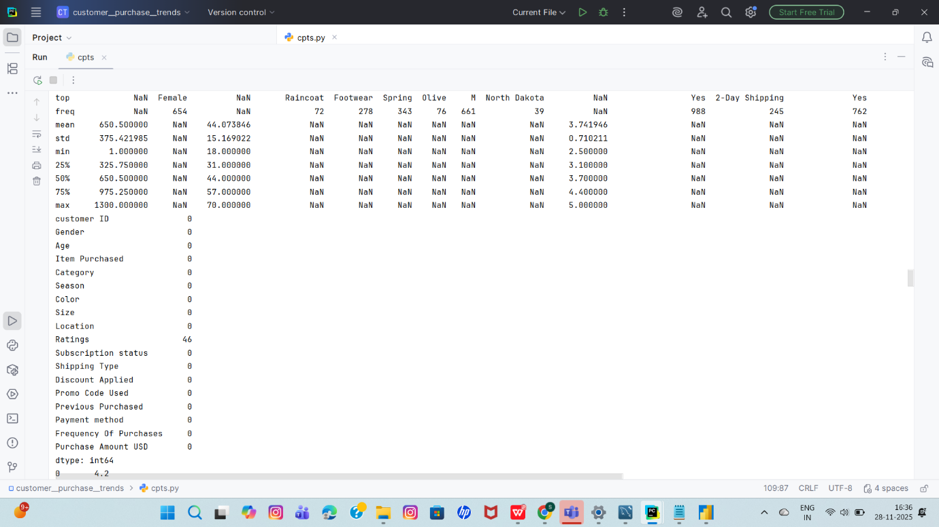

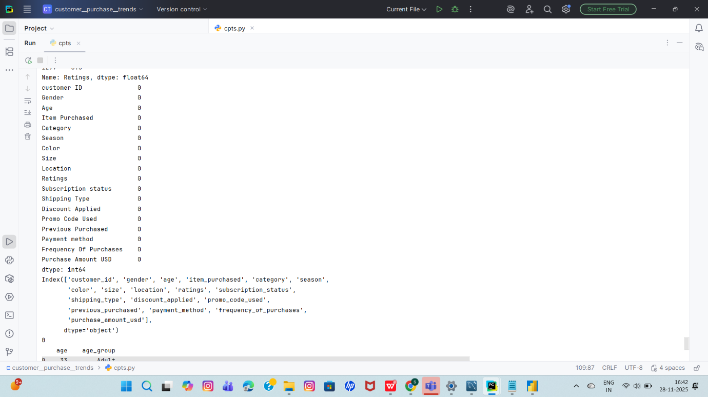

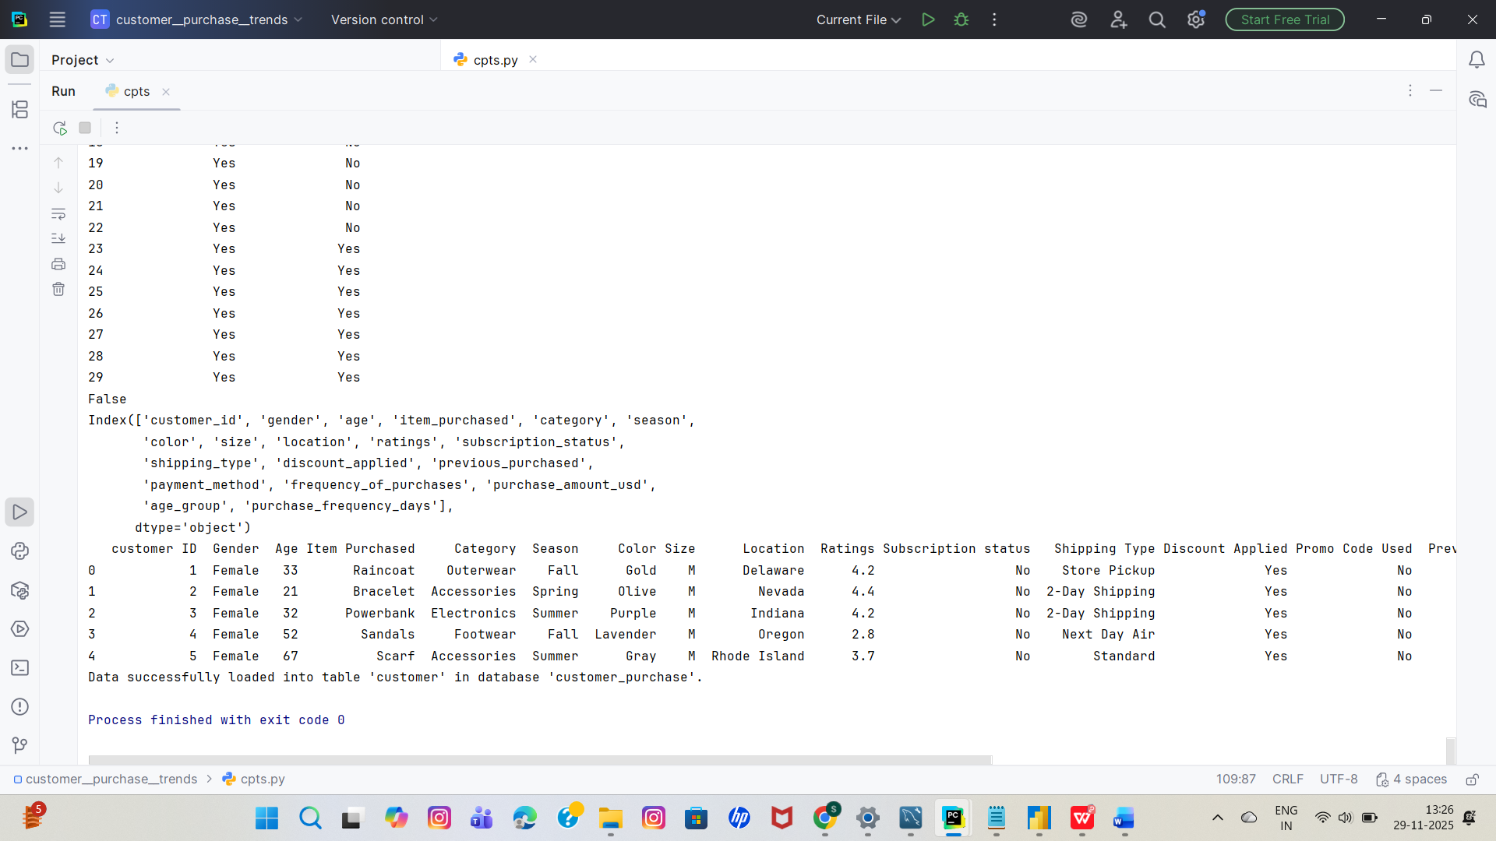

**4. Data Analysis using SQL (Business Transactions)**

We performed structured analysis in MySQL Workbench to answer key business questions:

**1. Total Number of Purchases**

Shows the total count of purchase records, indicating overall transaction volume.

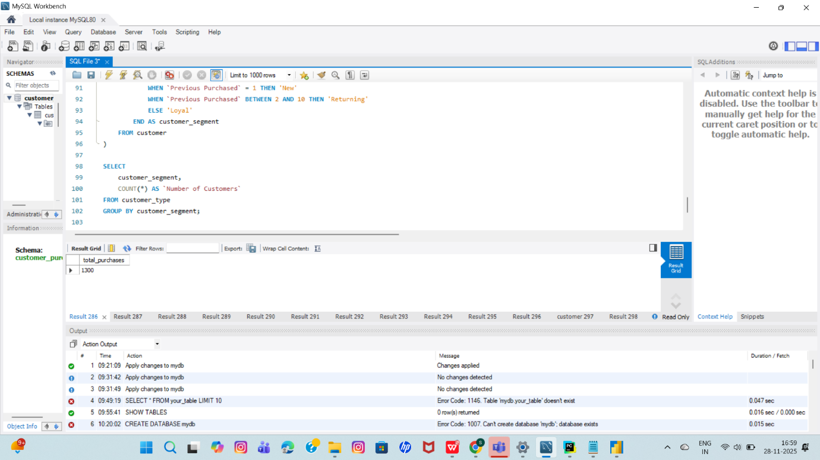

**2. Revenue by Gender**

Compares total revenue generated by each gender to understand spending distribution.

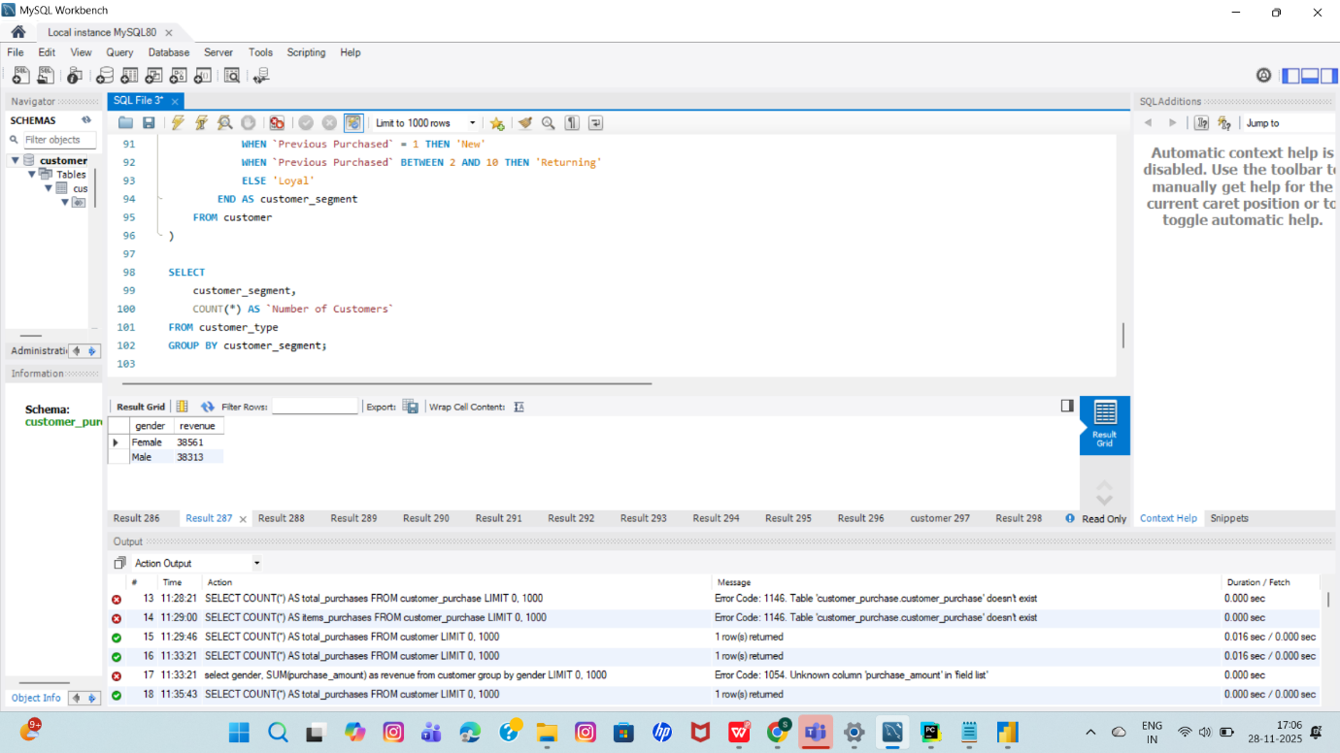

**3. Purchase Amount Summary**

Provides average, minimum, and maximum purchase amounts to understand customer spending patterns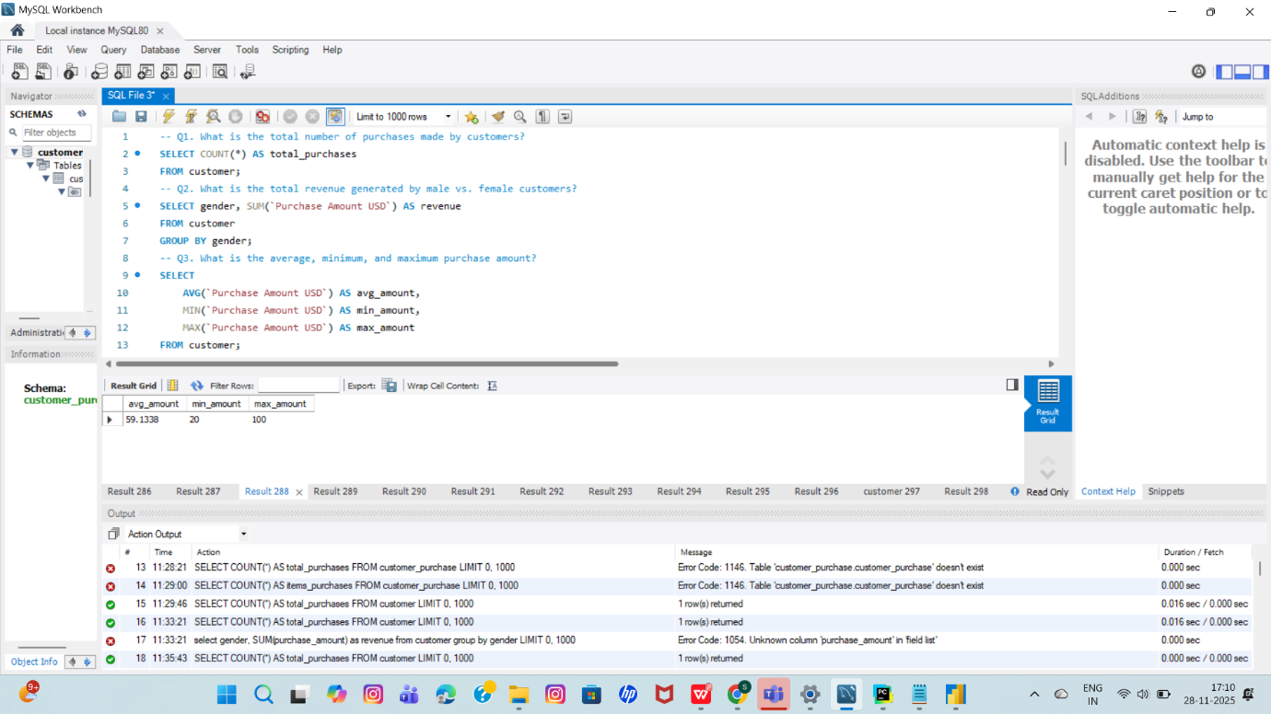

**4. Customer Distribution by Location**

Identifies which locations have the highest number of customers.

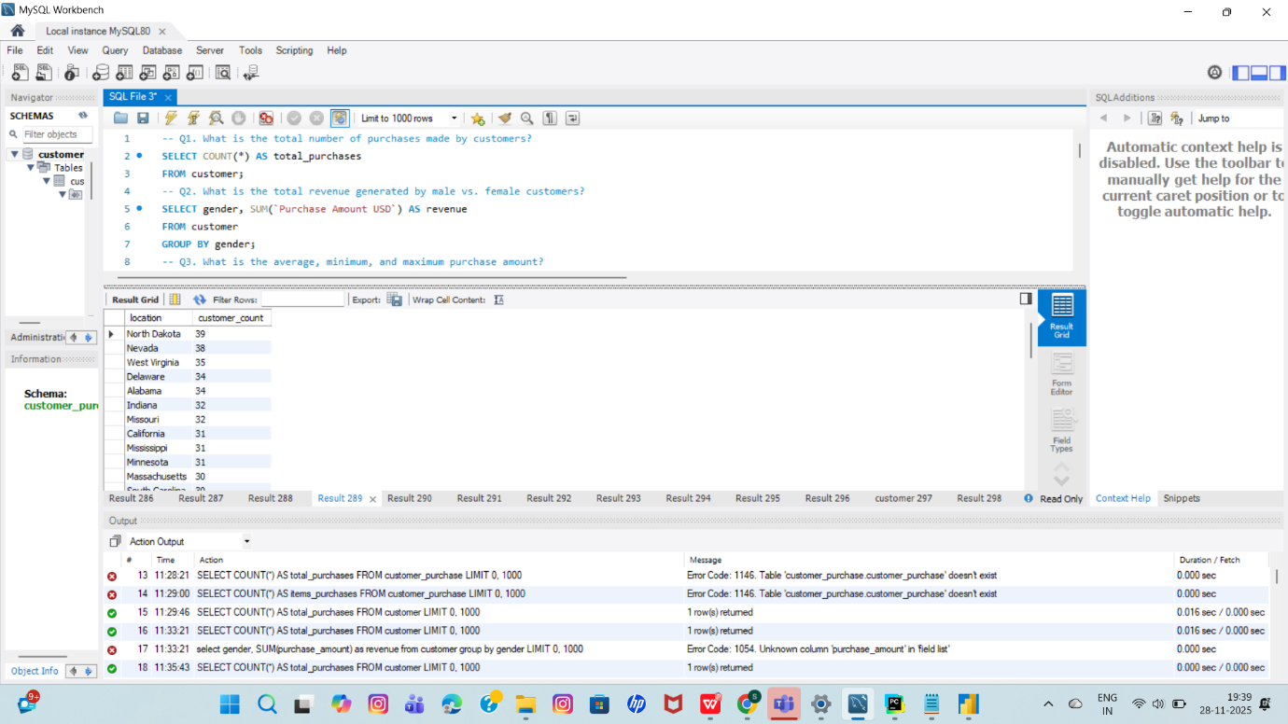

**5. Seasonal Purchase Volume**

Highlights the season that records the highest number of purchases.

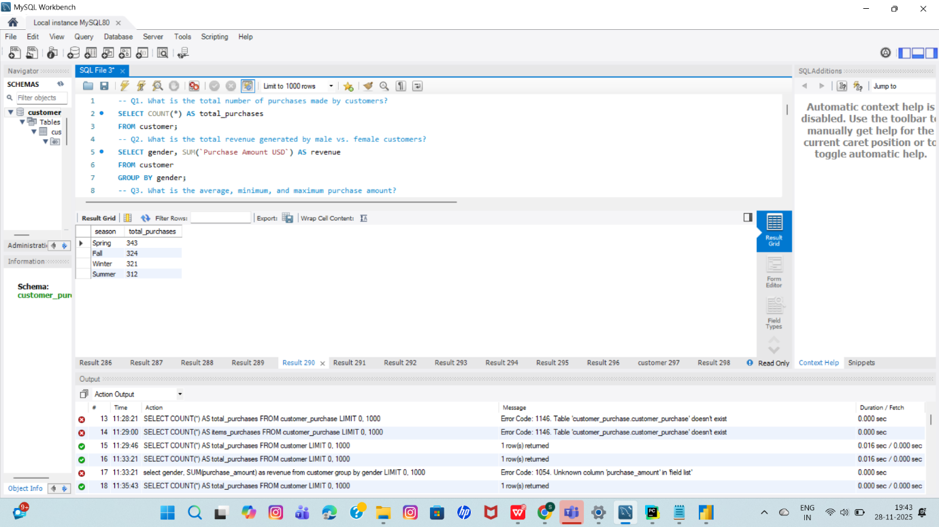

**6. Most Preferred Product Size**

Shows which product size is ordered the most by customers.

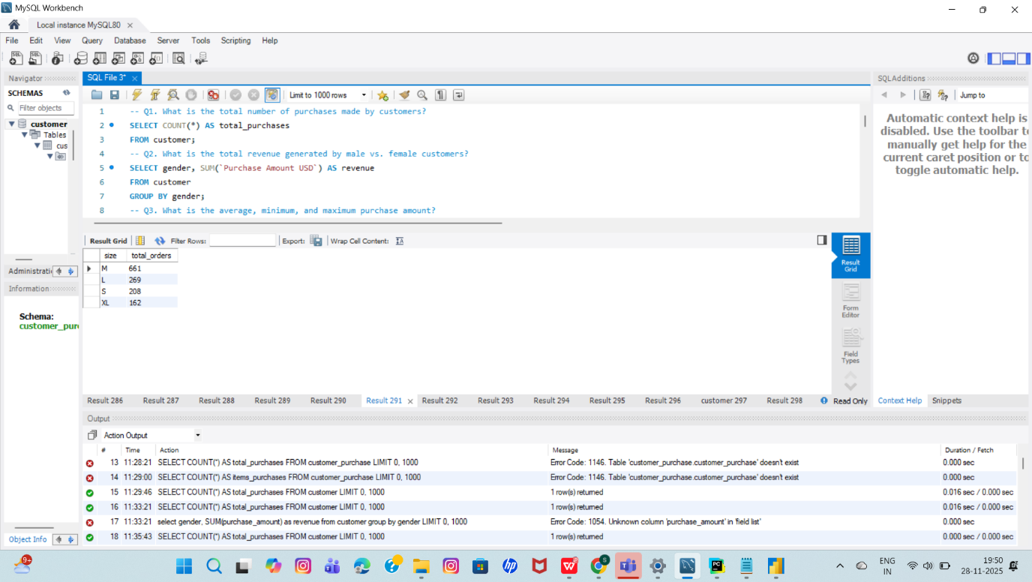

**7. Impact of Discounts on Spending**

Analyses whether applying a discount influences the average purchase amount.

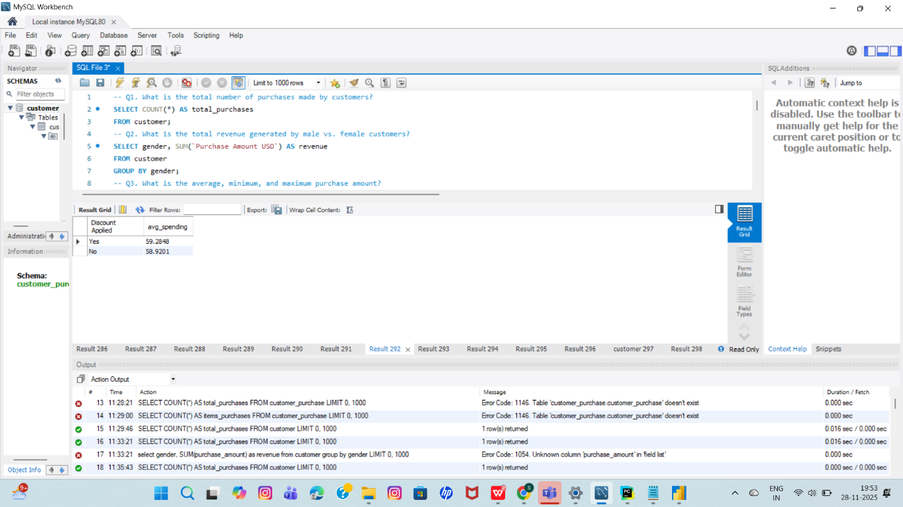

**8. Most Used Payment Method**

Identifies the most frequently used payment option among customers.

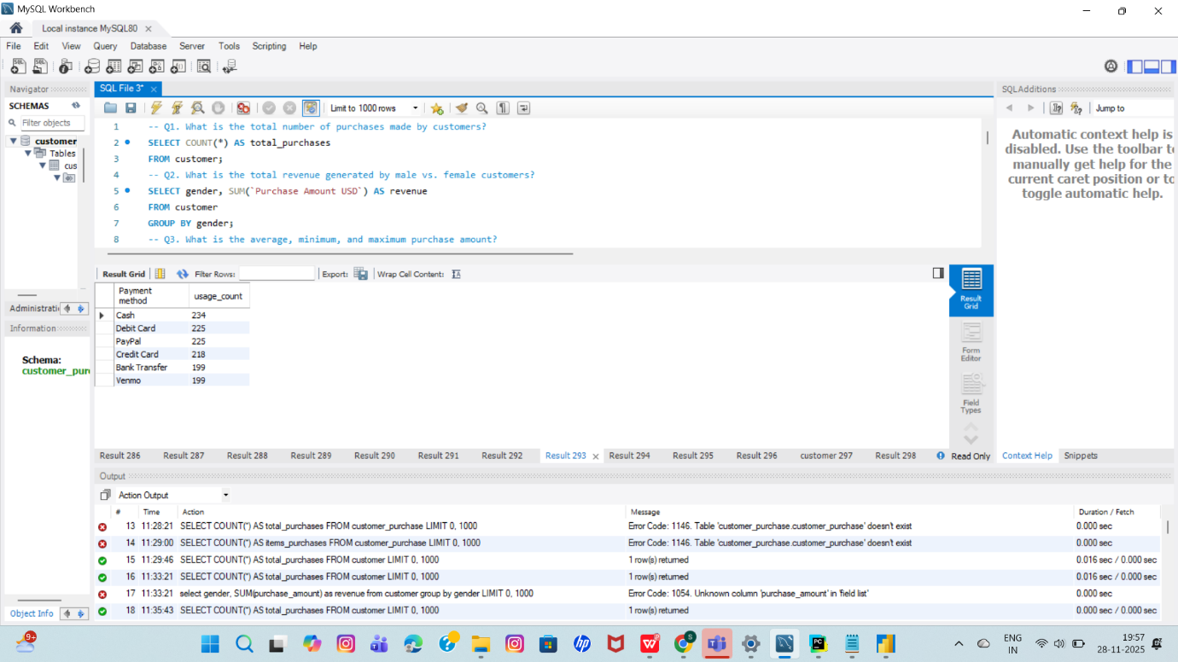

**9. Subscriber vs. Non-Subscriber Spending**

Compares average purchase amounts to determine whether subscribers spend more.

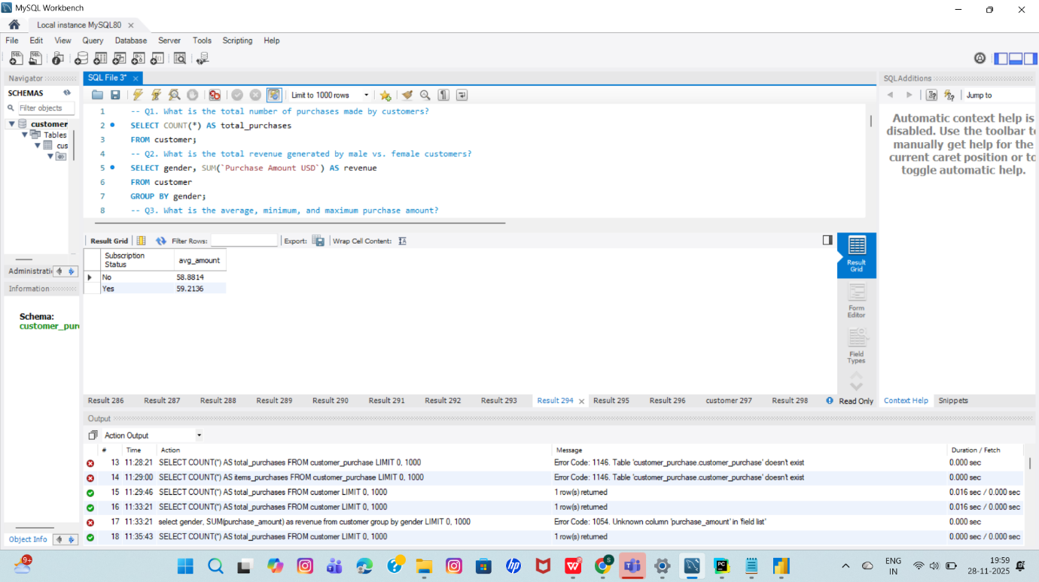

**10. Average Rating by Season**

Shows how customer review ratings change across different seasons.

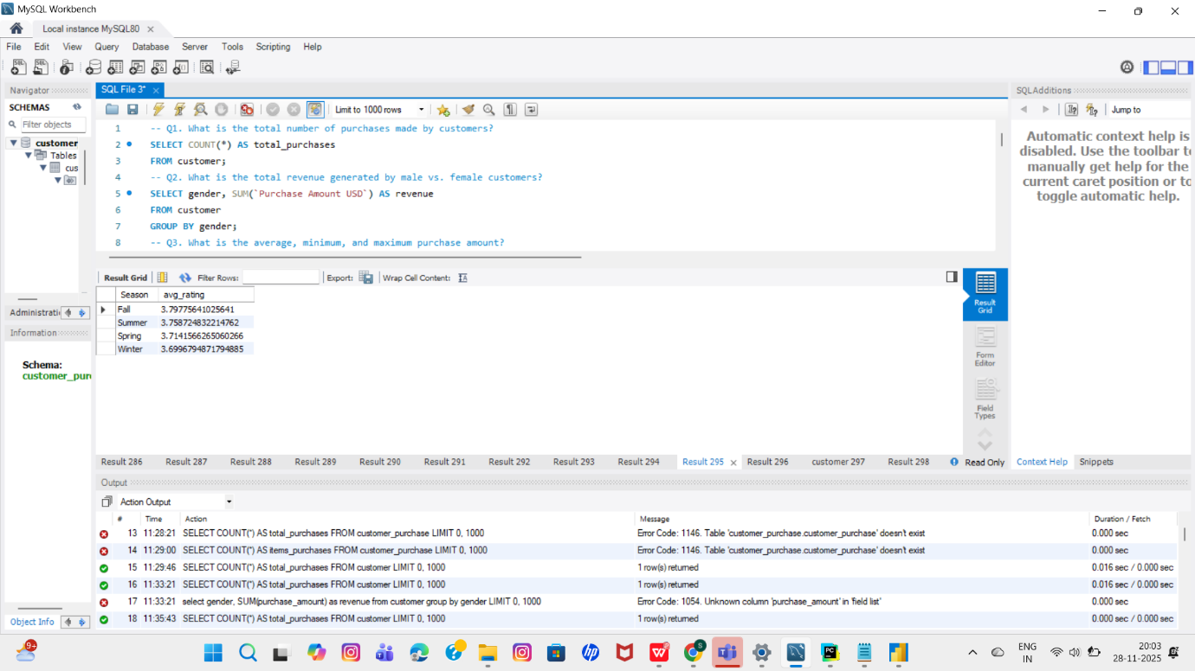

**11. Most Popular Colors**

Identifies the colors ordered most frequently by customers.

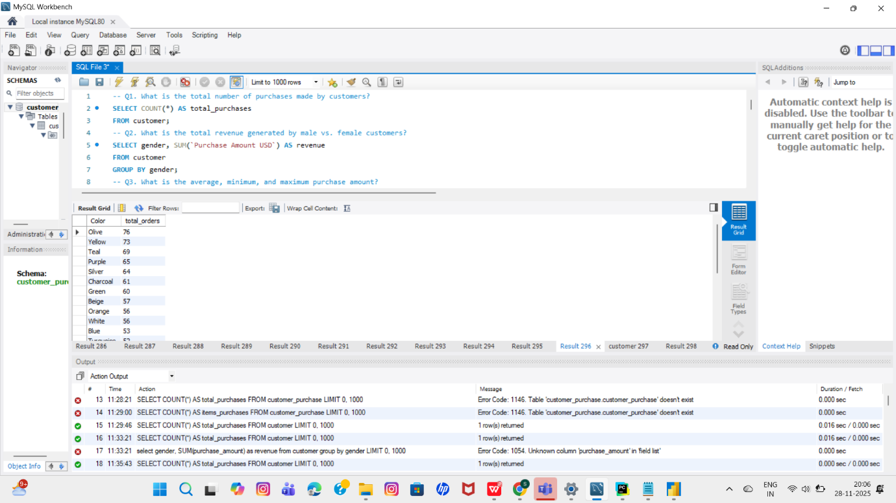

**12. High-Value Customers**

Finds customers whose purchase amount is above the overall average.

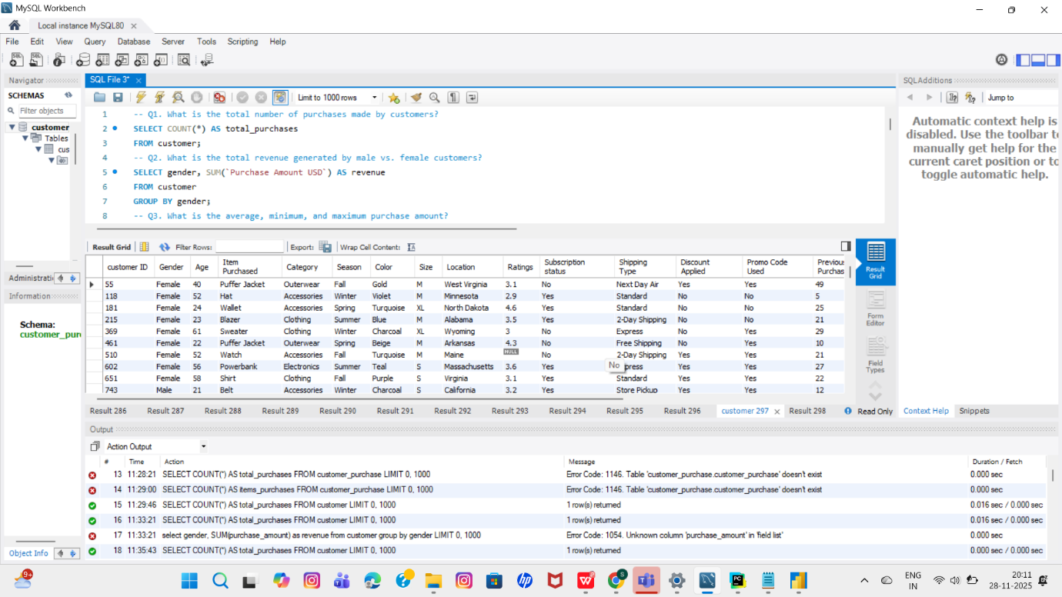

**13. Average Purchase Frequency**

Calculates the average number of days between customer purchases to understand buying habits.

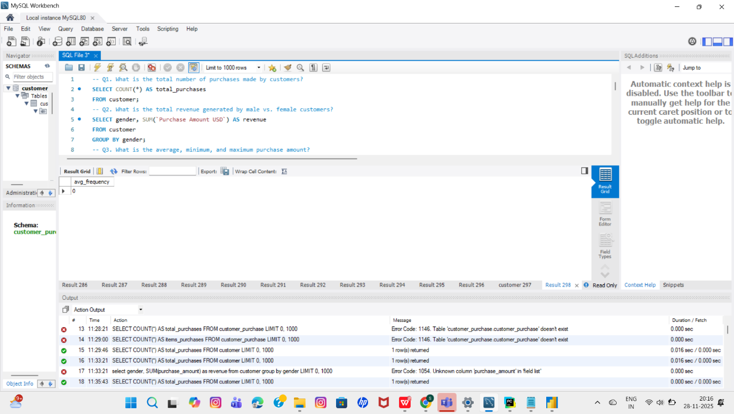

**14. Customer Segmentation (New, Returning, Loyal)**

Categorizes customers based on the number of previous purchases, helping analyze customer loyalty levels.

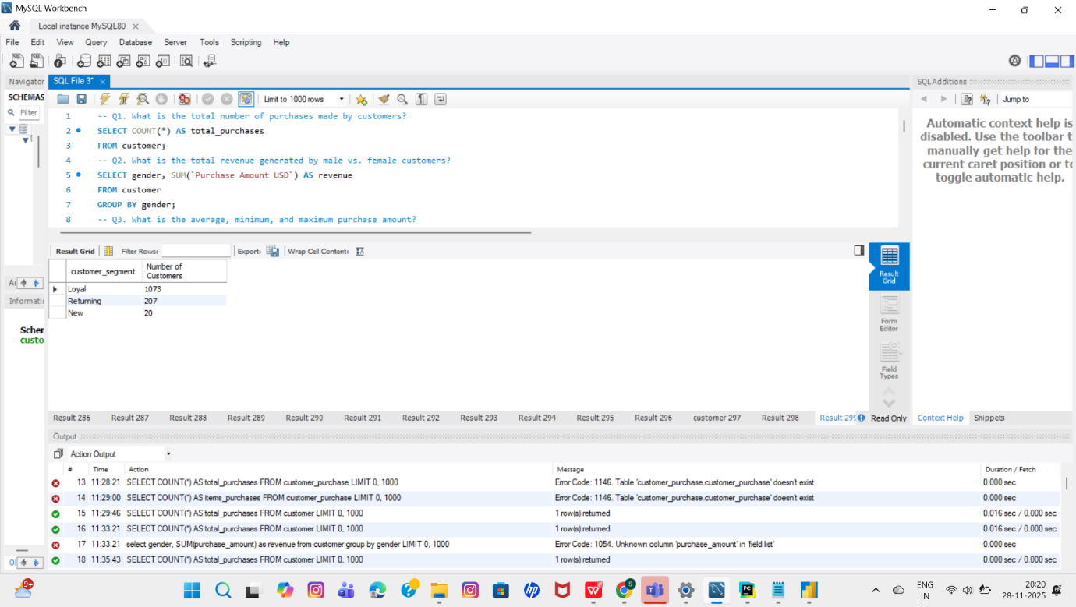

**5. Dashboard in Power BI**

Finally, we built an interactive dashboard in **Power BI** to present insights visually

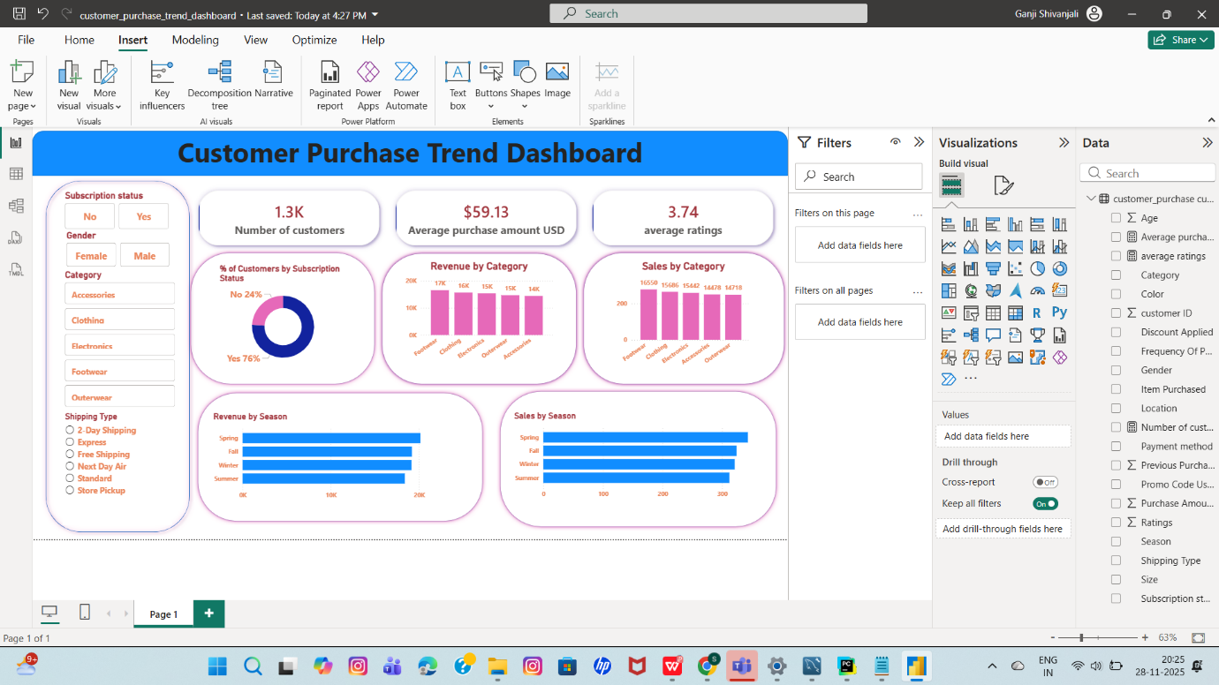

🧠 3. KEY BUSINESS INSIGHTS

⭐ Customers prefer Medium and Large sizes → plan more inventory.

⭐ Spring & Fall seasons show peak sales → run campaigns early.

⭐ Discount users spend slightly more/less.

⭐ Cash & Debit Card may be the most preferred payment mode.

⭐ Subscription members show higher average spending.

⭐ Certain colors (Olive, Yellow, Teal) trend higher.

⭐ Locations like North Dakota, Nevada & West Virginia may dominate orders.

⭐ A faster shipping method is preferred over standard delivery.

💼 4. BUSINESS RECOMMENDATIONS

1. Introduce targeted seasonal promotions

Boost marketing before high-demand seasons.

2. Offer loyalty or subscription rewards

Subscribers tend to spend more → increase retention.

3. Increase inventory for popular sizes & colors

Avoid out-of-stock situations.

4. Promote items with high review ratings

High-rated items convert better.

5. Provide discounts on low-performing categories

Encourages inventory clearance.

6. Focus marketing on high-purchase cities

Cities with higher orders deserve localized campaigns.

7. Improve shipping speed

If express shipping is more popular → reduce shipping time.

8. Personalize product recommendations

Use purchase frequency + style preferences.